Zoning Case No. ZN8340, Cypress Point Capital LLC (District 5).
Ordinance rezoning a property at or near Farm-to-Market Road 2444 (FM-2444/Staples Street) and County Road 43 (CR-43) from the “FR” Farm Rural District to the “CN-1” Neighborhood Commercial District and the “RS-22” Single-Family District; providing for a penalty not to exceed $2,000 and publication. (Planning Commission and Staff recommend approval).

WHEREAS, with proper notice to the public, a public hearing was held during a meeting of the Planning Commission, during which all interested persons were allowed to appear and be heard;

WHEREAS, the Planning Commission has forwarded to the City Council its final report and recommendation regarding the application for an amendment to the City of Corpus Christi’s Unified Development Code (“UDC”) and corresponding UDC Zoning Map;

WHEREAS, with proper notice to the public, a public hearing was held during a meeting of the City Council, during which all interested persons were allowed to appear and be heard;

WHEREAS, the City Council has determined that this rezoning is not detrimental to the public health, safety, or general welfare of the City of Corpus Christi and its citizens; and

WHEREAS, the City Council finds that this rezoning will promote the best and most orderly development of the properties affected thereby, and to be affected thereby, in the City of Corpus Christi.

NOW, THEREFORE, BE IT ORDAINED BY THE CITY COUNCIL OF THE CITY OF CORPUS CHRISTI, TEXAS, THAT:

SECTION 1. The Unified Development Code (“UDC”) and corresponding UDC Zoning Map of the City of Corpus Christi, Texas are amended by changing the zoning on the subject property being 18.72 acres of the 37.44 Acres out of the S/2 of Section 30, Laureles Farm Tracts, as described and shown in Exhibit “A” and “B”, from:

the (Planning Commission and Staff Recommendation) to the (Planning Commission and Staff Recommendation).

The subject property is located at or near Farm-to-Market Road 2444 (FM-2444/Staples Street) and County Road 43 (CR-43). Exhibit A, a metes and bounds description with exhibit, and Exhibit B, a map, are attached to and incorporated in this ordinance.

SECTION 2. The UDC and corresponding UDC Zoning Map of the City, made effective July 1, 2011 and as amended from time to time, except as changed by this ordinance, both remain in full force and effect including the penalties for violations as made and provided for in Article 10 of the UDC.

SECTION 3. To the extent this amendment to the UDC represents a deviation from the City’s Comprehensive Plan, the Comprehensive Plan is amended to conform to the UDC, as it is amended by this ordinance.

SECTION 4. All ordinances or parts of ordinances specifically pertaining to the zoning of the subject property that conflict with this ordinance are hereby expressly superseded except for the Military Compatibility Area Overlay Districts. This ordinance does not amend or supersede any Military Compatibility Area Overlay Districts, which, as adopted by Ordinance #032829, remain in full force and effect.

SECTION 5. A violation of this ordinance, or requirements implemented under this ordinance, constitutes an offense punishable by a fine not to exceed $2,000.00 for each offense; as provided in Article 1, Section 1.10.1 of the UDC, Article 10 of the UDC, and/or Section 1-6 of the Corpus Christi Code of Ordinances.
SECTION 6. Publication shall be made in the official publication of the City of Corpus Christi as required by the City Charter.

SECTION 7. This ordinance shall become effective upon publication.

Introduced and voted on the _____ day of ________________, 2024.
PASSED and APPROVED on the _____ day of ________________, 2024.
ATTEST:

Paulette Guajardo, Mayor Rebecca Huerta, City Secretary

- Metes & Bounds Description and Exhibit
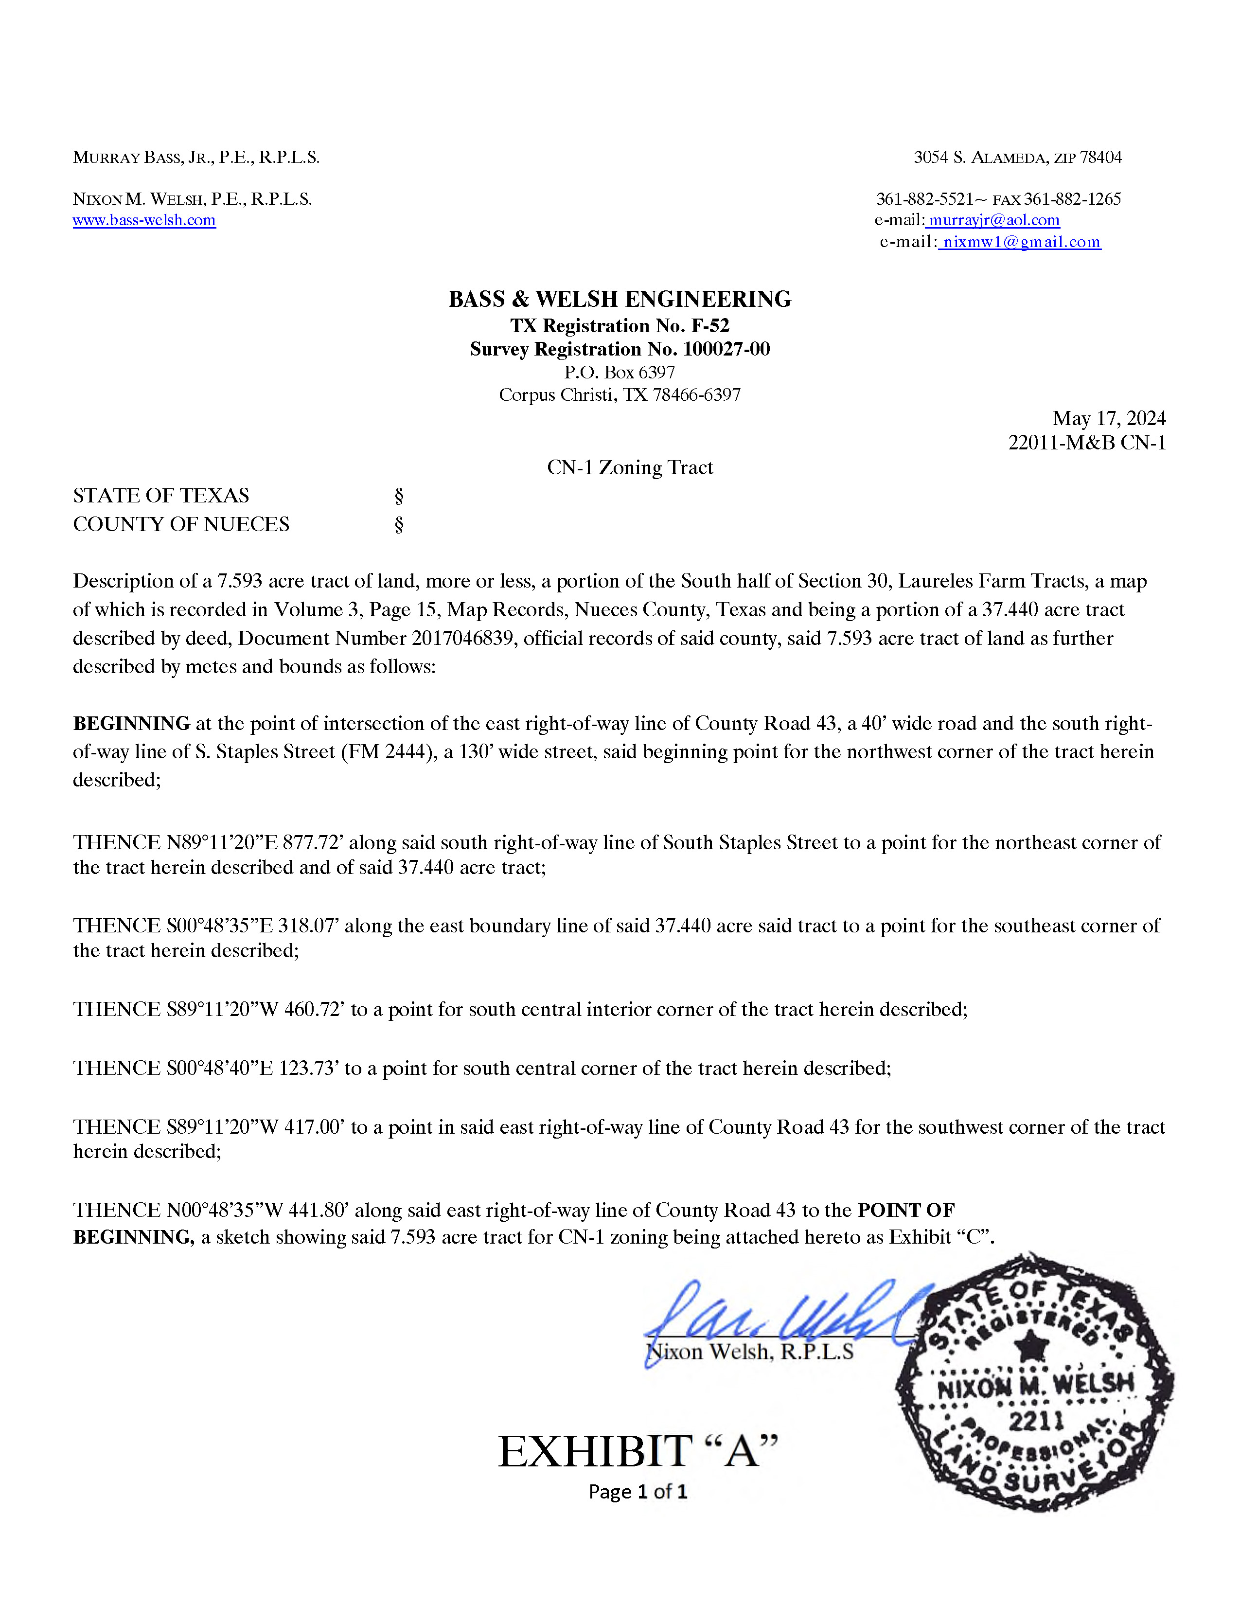

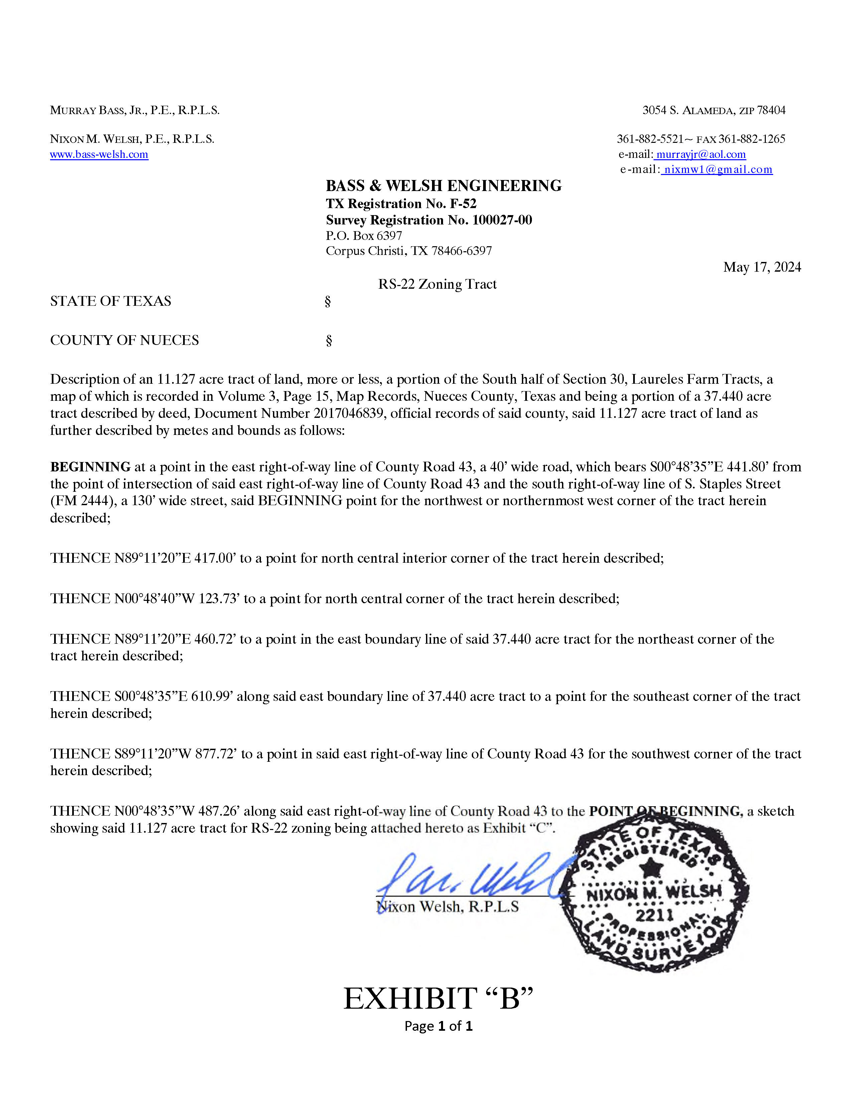

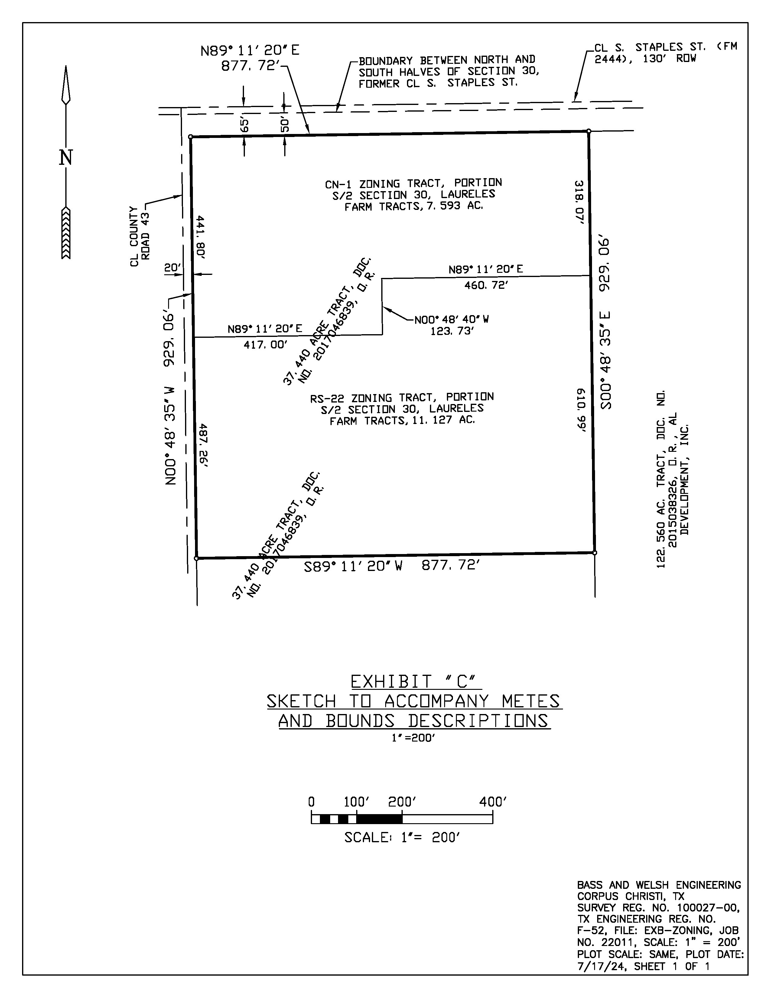

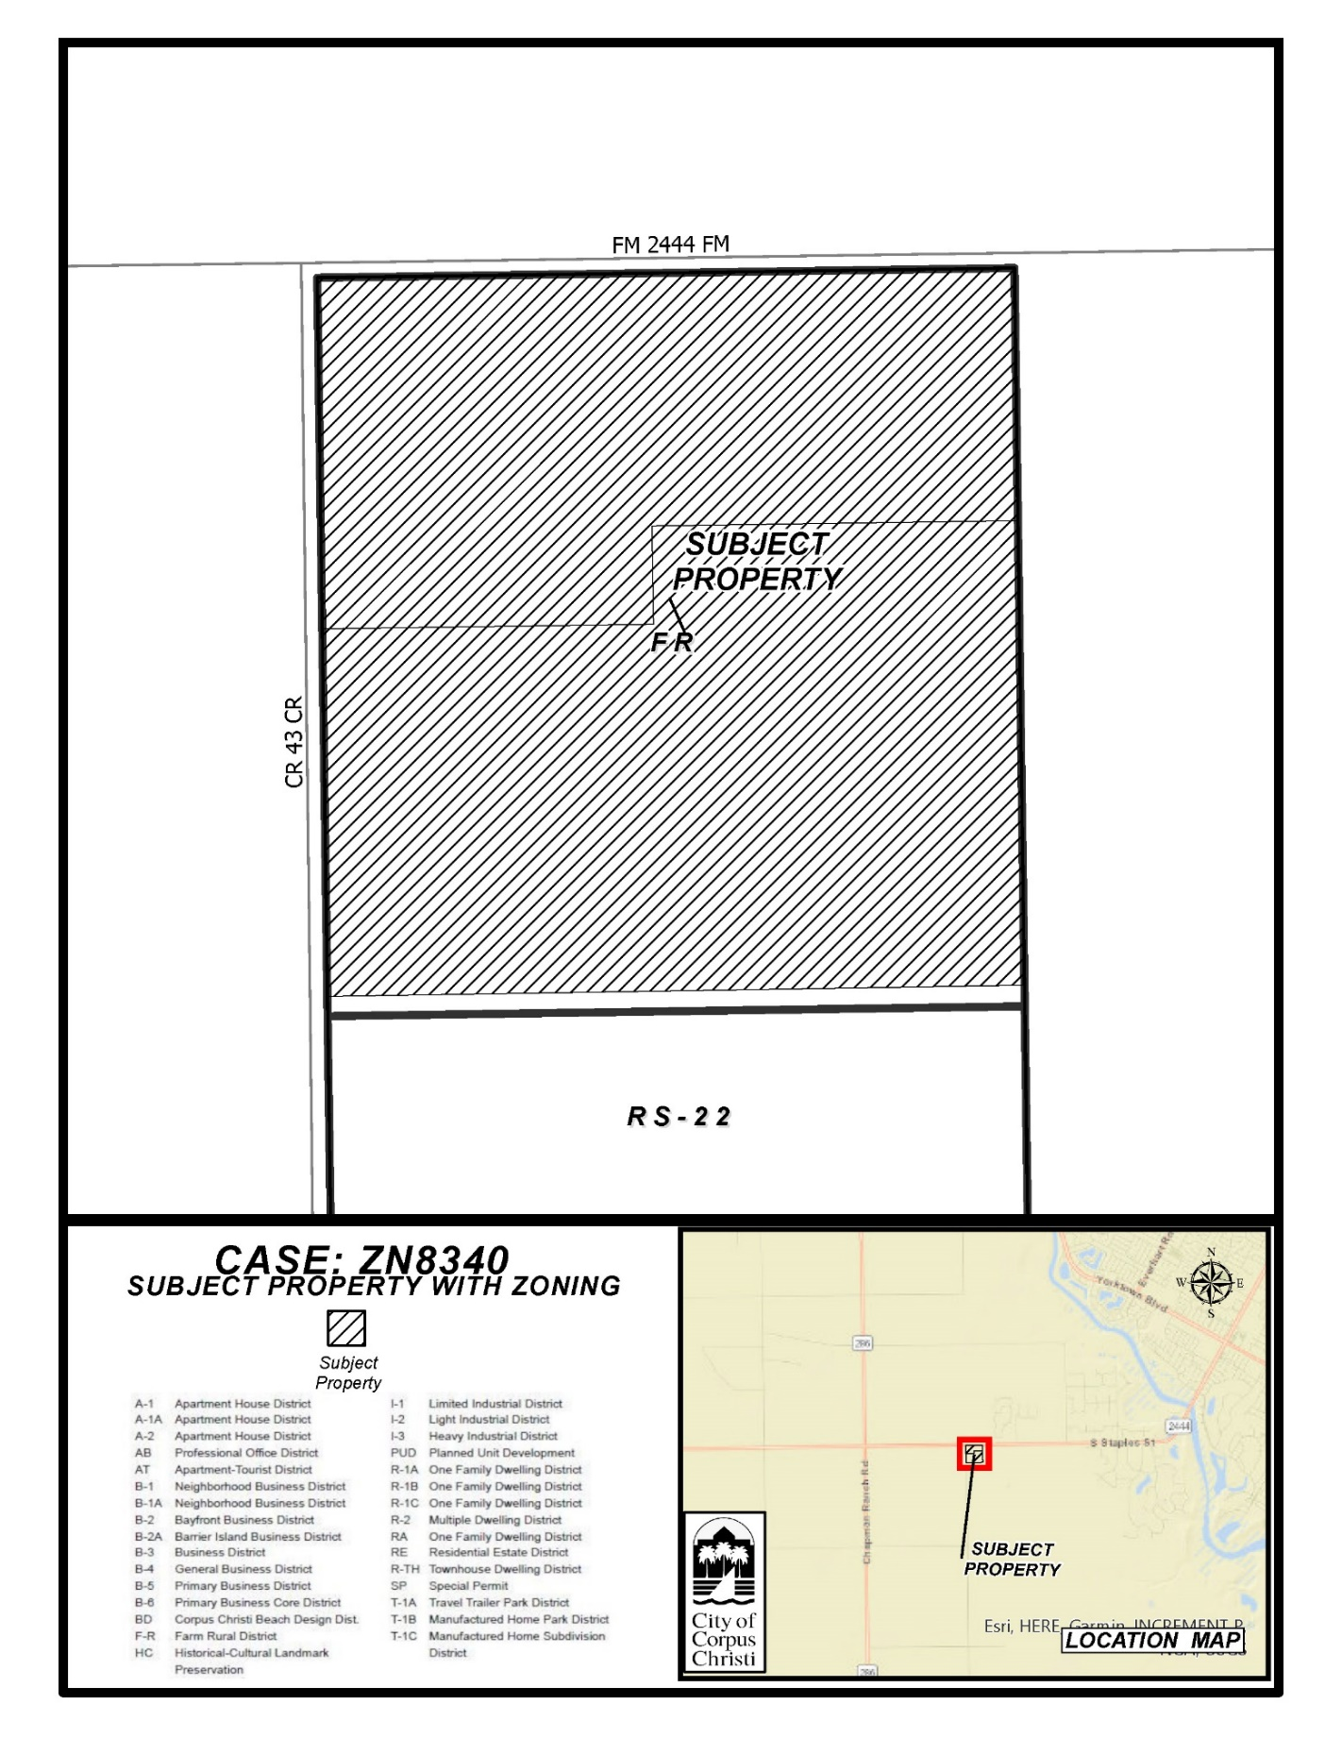
(B) Existing Zoning and Notice Area Map

