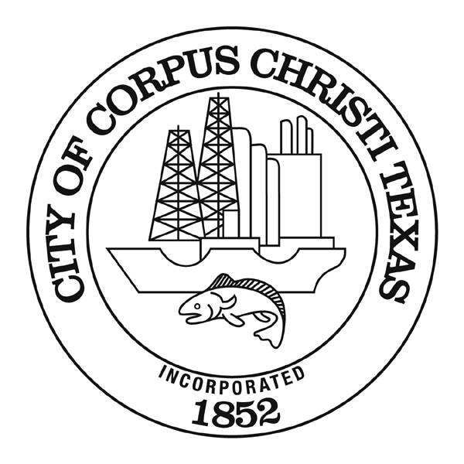
AGENDA MEMORANDUM
Action Item for the City Council Meeting January 14, 2025

DATE: January 14, 2025

TO: Peter Zanoni, City Manager

FROM: Jeff H. Edmonds, P. E., Director of Engineering Services
jeffreye@cctexas.com
(361) 826-3851

Acceptance of legal responsibility for the Michael J. Ellis (North Padre Island) Seawall

CAPTION:
Resolution to accept the easements that dedicate the Michael J. Ellis Seawall on North Padre Island, located in District 4, to the City, and the City is taking on legal responsibility to maintain and repair the Seawall in accordance with Article X of the City Charter.
SUMMARY:
The resolution accepts the easements that dedicate the Michael J. Ellis Seawall on North Padre Island to the City. The City has legal responsibility and authority to maintain and repair the Seawall in accordance with state and federal law and perform disaster-related restoration of the Seawall.

BACKGROUND AND FINDINGS:

The Micheal J. Ellis Seawall and Beach is a popular destination for both tourists and locals. The seawall was originally built in the late 1960’s by the Padre Island Investment Corporation (PIIC). In 1980, Hurricane Allen severely damaged the seawall. Since it was privately owned, the extensive repairs were not eligible for FEMA Public Assistance (PA). The adjoining owners had to assess themselves to make the needed repairs. For repairs to qualify for FEMA PA funding in the event of damage from a future disaster, the Seawall must fall under the legal responsibility of a political subdivision.

During the council meeting of August 27, 2024, Council approved a motion to acquire easements for the North Padre Island Seawall Improvements project. On December 10, 2024, the City secured all easements from the 15 tracts fronting the seawall. The easements grant the City ownership of the Seawall and the legal responsibility of repairing and maintenance of the North Padre Island Seawall. The Seawall will become a public asset like any other privately built infrastructure that is dedicated to the public such as streets or utility infrastructure. The City has the right to construct, maintain, repair, reconstruct, and operate the seawall as a retaining wall for erosion control and pedestrian use. By formally accepting the North Padre Island Seawall as public asset, the Seawall is eligible for FEMA PA funding in the event of damage from a future disaster.

On July 18, 2023, and subsequently on July 23, 2024, the Tax Increment Reinvestment Zone (TIRZ) #2 Board approved a total of $3,900,000 in the FY24 and FY25 Budget for the North Padre Seawall Repairs. A total budget of $15 million was allocated to the North Padre Island Michael J. Ellis Seawall Improvement Project.

The City Council awarded a contract to Hanson on December 10, 2024 to produce bid documents for the contemplated seawall repairs and upgrades. That effort is underway. Staff is planning to sequence activities so that construction can begin as soon as possible after Labor Day this year.

ALTERNATIVES:

Council can choose not to accept legal maintenance responsibility for the Michael J. Ellis (North Padre Island) Seawall. Individual property owners will remain responsible for the seawall maintenance.

FINANCIAL IMPACT:

No financial impact to approving this resolution.

RECOMMENDATION:

Staff recommends approval of resolution to accept the legal maintenance responsibility for the Michael J. Ellis (North Padre Island) Seawall.

LIST OF SUPPORTING DOCUMENTS:

Resolution
Location and Vicinity Maps

