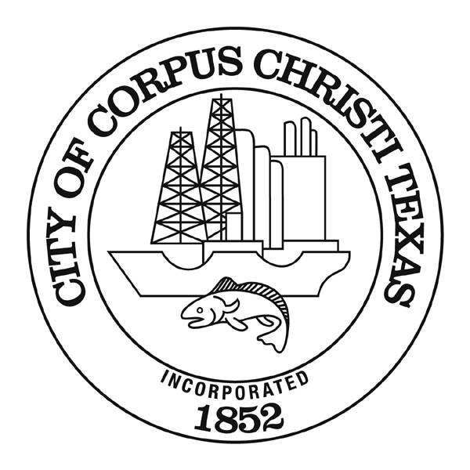

AGENDA MEMORANDUM
Action Item for the City Council Meeting of January 14, 2025

DATE: January 14, 2025

TO: Peter Zanoni, City Manager

FROM: Jeff H. Edmonds, P. E., Director of Engineering Services
jeffreye@cctexas.com
(361) 826-3851

Ernesto De La Garza, P.E., Director of Public Works
ernestod2@cctexas.com
(361) 826-1677

Sergio Villasana, CTCD, Director of Finance & Procurement
joshc2@cctexas.com
(361) 826-3169

Construction Contract Award
Aaron Drive – Saratoga Blvd. to Summer Wind Drive
(Bond 2022, Proposition A)

CAPTION:

Motion authorizing a construction contract with Grace Paving and Construction, Inc. from Corpus Christi, Texas, for the reconstruction of Aaron Drive from Saratoga Blvd. to Summer Wind Drive with new asphalt pavement, 5-ft sidewalks, curbs, gutters, ADA-compliant curb ramps, signage, and utility improvements in an amount not to exceed $3,840,880.73, located in Council District 5 with funding available from the 2022 Street Bond and FY2025 Storm Water, Wastewater, Water, and Gas funds.

SUMMARY:

This motion awards a construction contract to Grace Paving and Construction, Inc. for the complete reconstruction of Aaron Drive from Saratoga Blvd. to Summer Wind Drive. The existing roadway will be demolished and rebuilt with new asphalt pavement, curbs and gutters, 5-ft sidewalks, ADA-compliant curb ramps, and new street signage. In addition to surface improvements, the project includes stormwater, water, and wastewater infrastructure enhancements.

BACKGOUND AND FINDINGS:

On November 8, 2022, voters approved the City of Corpus Christi’s Bond 2022 Program for a total of $125 million with thirty-two projects. The propositions passed on election day included projects for streets, parks, public safety, and library improvements. One of the thirty-two projects is the $2.2 million reconstruction of Aaron Drive between Saratoga Blvd. and Summer Wind Drive.

The project limits are Aaron Drive between Saratoga Blvd. and Summer Wind Drive, spanning approximately 2,400 linear feet (equal to 0.45 miles). According to the City’s Urban Transportation Plan, this section of Aaron Drive is classified as a C-1 Residential Collector. Aaron Drive is currently a two-lane, hot-mix asphalt concrete (HMAC) roadway with one travel lane in each direction, on-street parking on each side, a 6-ft standard curb and gutter, 4-ft sidewalks, with an average width of 40 feet from back-of-curb to back-of-curb.

The project scope of improvements includes the complete reconstruction of the existing roadway with new asphalt pavement, curbs and gutters, and 5-ft sidewalks. Additionally, the project includes the installation of ADA-compliant curb ramps, signage, and the relocation of light poles. Alongside the street enhancements, Storm Water, Water, and Wastewater utilities will undergo improvements to align with current City standards.

Aaron Drive, from Saratoga Blvd. to Summer Wind Drive, was designed for asphalt pavement only, based on the pavement design recommendations approved by the City Council on May 21, 2024.

PROJECT TIMELINE:

2023 - 2024 | 2024 - 2025 | 2025 - 2026
October - September | October - January | February - February
Design | Bid/Award | Construction

Project schedule reflects City Council award in January 2025 with anticipated completion by February 2026.

COMPETITIVE SOLICITATION PROCESS

On October 21, 2024, the Contracts and Procurement Department issued a Request for Bids (RFB #6122) for Aaron Drive from Saratoga Blvd. to Summer Wind Drive. The solicitation contained only an asphalt pavement base bid, which was based on the pavement design recommendations for the Bond 2022 Streets projects approved by City Council on May 21, 2024.

On November 20, 2024, the city received bids from seven bidders. The city analyzed the bids in accordance with the contract documents and determined that Grace Paving and Construction, Inc. was the lowest responsive and responsible bidder. The Engineer’s Opinion of Probable Construction Cost was estimated based on the historic data. The construction cost has been stabilized, and the bids are coming in lower.

A summary of the bids is provided below:

 | Bidder | Base Bid  (Asphalt Pavement)
1 | Grace Paving and Construction, Inc. | $3,840,880.73
2 | Max Underground Construction | $3,978,942.12
3 | Bay Ltd | $4,162,821.20
4 | A. Ortiz Construction & Paving, Inc. | $4,406,189.83
5 | Mako Contracting | $4,522,287.05
6 | JE Construction Services | $4,684,683.00
7 | Mor-Will, L.L.C | $5,207,346.81
 | Engineer’s Opinion of Probable Construction Cost | $5,200,000.00

Grace Paving and Construction, Inc., is the low bidder for the base bid. The company has successfully completed many construction projects with the City of Corpus Christi. Recently completed projects include Strasbourg Drive from Riom Street to Grenoble Drive (Bond 2018), Minor Street Improvements IDIQ, and seventeen streets within the scope of the Residential Street Rebuild Program.

Based on the review, city staff recommend that the City award the construction contract to the low bidder, Grace Paving and Construction, Inc.

ALTERNATIVES:

The council could choose not to award the contract to Grace Paving and Construction, Inc. This decision would delay the project and conflict with the City Council's goal of expediting street projects using bond funds.

FISCAL IMPACT:

The proposal is to award a construction contract to Grace Paving and Construction, Inc in an amount not to exceed $3,840,880.73, for the reconstruction of Aaron Drive from Saratoga Blvd. to Summer Wind Drive. Project funds are available from the 2022 Street Bond and FY2025 Storm Water, Wastewater, Water, and Gas allocations.

Funding Detail:

The Capital Improvement Program (CIP) shows the project is currently scheduled to begin construction in FY 2025. The project is ready to be implemented.

Fund: 2024 GO Bd22 Prop A (Fund 3561)
Department: Streets (33)
Organization: Grants & Capital Projects Funds (89)
Project: Aaron Drive (Saratoga to Summer Winds) (Project No. 23164)
Account: Construction Contract (550910)
Activity: 23164
Amount: $1,806,061.97

Fund: Gas 2023 CIP (Fund 4562)
Department: Gas (11)
Organization: Grants & Capital Projects Funds (89)
Project: Aaron Drive (Saratoga to Summer Winds) (Project No. 23164)
Account: Construction Contract (550910)
Activity: 23164
Amount: $26,532.84

Fund: STWCP RR 032950 2023 (Fund 4536)
Department: Storm Water (47)
Organization: Grants & Capital Projects Funds (89)
Project: Aaron Drive (Saratoga to Summer Winds) (Project No. 23164)
Account: Construction Contract (550910)
Activity: 23164
Amount: $550,151.39

Fund: WWWCP RR 032950 2023 (Fund 4260)
Department: Wastewater (46)
Organization: Grants & Capital Projects Funds (89)
Project: Aaron Drive (Saratoga to Summer Winds) (Project No. 23164)
Account: Construction Contract (550910)
Activity: 23164
Amount: $689,286.46

Fund: Water 2024 CIP (Fund 4491)
Department: Water (45)
Organization: Grants & Capital Projects Funds (89)
Project: Aaron Drive (Saratoga to Summer Winds) (Project No. 23164)
Account: Construction Contract (550910)
Activity: 23164
Amount: $768,848.07

Total: $3,840,880.73

RECOMMENDATION:

Staff recommends awarding the construction contract to Grace Paving and Construction, Inc. for the reconstruction of Aaron Drive from Saratoga Blvd. to Summer Wind Drive in the amount of $3,840,880.73 with construction duration planned for 16 months from issuance of the Notice to Proceed with construction starting in February 2025 and completed by February 2026.

LIST OF SUPPORTING DOCUMENTS:
Resolution
Location Map
Bid Tabs (Base Bid)
CIP Page
Power Point Presentation

