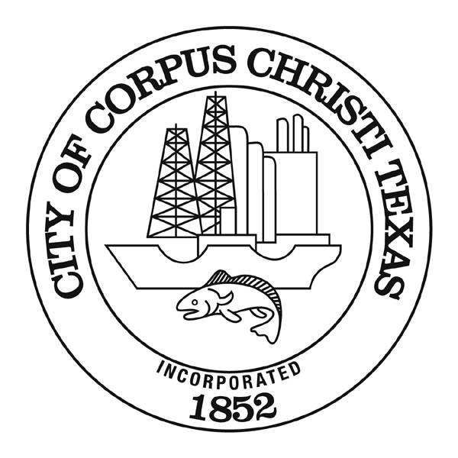
AGENDA MEMORANDUM
First Reading Ordinance for the City Council Meeting January 14, 2025
Second Reading Ordinance for the City Council Meeting January 28, 2025

DATE: January 14, 2025

TO: Peter Zanoni, City Manager

FROM: Brandon Wade, Fire Chief
brandonw@cctexas.com
(361) 826-3900

Acceptance of a grant totaling $32,016.60 from Gulf of Mexico Alliance for the Gulf Star Grant for the Corpus Christi Fire Department’s Office of Emergency Management

CAPTION:

Ordinance authorizing the acceptance of a grant totaling $32,016.60 from Gulf of Mexico Alliance for the 2024 Gulf Star Program Grant for the purchase of 13 new L3Harris inter-operational radios and related accessories for the Corpus Christi Fire Department’s Office of Emergency Management; and appropriating $32,016.60 in the FY 2025 Fire Grants Fund.

SUMMARY:

This ordinance authorizes accepting and appropriation of a grant totaling $32,016.60 from Gulf of Mexico Alliance for the Gulf Star Program Grant. The funding will be for the purchase of 13 new L3Harris inter-operational radios and related accessories for the Corpus Christi Fire Department’s Office of Emergency Management.

BACKGROUND AND FINDINGS:

The Gulf Star Grant is a grant opportunity through the Gulf of Mexico Alliance. The Gulf of Mexico Alliance was created in 2004 and is an American partnership network that focuses on common issues in the Gulf of Mexico region. It includes state and federal agencies, tribal governments, communities, academic organizations, businesses, and non-governmental organizations. The Gulf of Mexico Alliance's goals include providing collaboration forums, developing tools to address regional issues, enabling strategic partnerships, and tracking restoration efforts. Its mission is to enhance the environmental and economic health of the Gulf of Mexico through increased regional collaboration. The Gulf of Mexico Alliance is the Regional Ocean Partnership for the Gulf of Mexico, designated by the governors of the five Gulf state (Alabama, Florida, Louisiana, Mississippi, and Texas). Each of the five Gulf states has committed time and resources to its management, including leadership of their Priority Issue Teams. The success of the Gulf of Mexico Alliance is based not only on the dedication of the five Gulf states, but also on commitment from federal partners. In particular, the Alliance relies heavily on participation from U.S. EPA, NOAA, U.S. Fish and Wildlife Service, Gulf Coast Ecosystem and Restoration Council, U.S. Department of Treasury, and U.S. Department of Defense.

The organization of the Gulf of Mexico Alliance includes a small headquarters staff and several committees, working groups, and teams dedicated to addressing the priorities issues identified by the Gulf states as those that would benefit from a regional approach. The structure of how this organization functions is as follows:

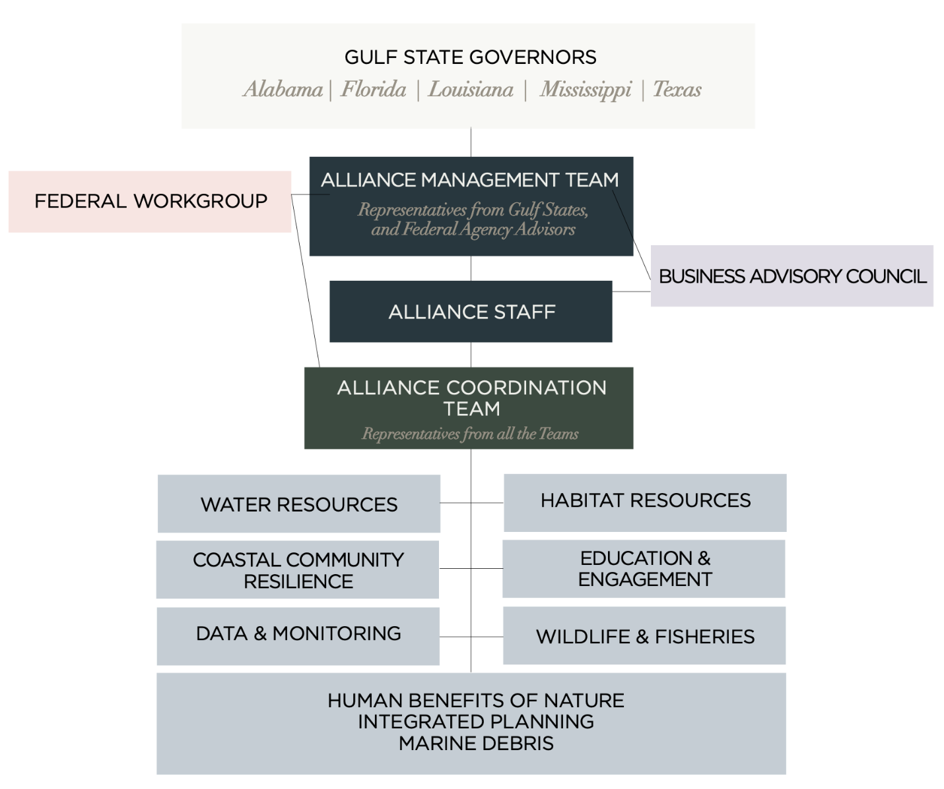

The Alliance Management Team is comprised of representatives of the five Gulf state governors with federal agencies and other organizations serving in advisory capacity.

The Alliance Coordination Team is comprised of representatives from each of the Priority Issue Teams, including state chairs, coordinators, and federal liaisons.

Priority Issue Teams and Cross-Team Initiatives are the hallmark of the Gulf of Mexico Alliance. These state-led teams focus on well-defined issues and are key to the success. Participation in the teams are open and voluntary. Specific actions are developed and implemented by the voluntary participants of the teams. In the Governors’ Action Plan IV, the Alliance is addressing these priorities: Coastal Community Resilience, Data & Monitoring, Habitat Resources, Education & Engagement, Water Resources, Human Benefits of Nature, Integrated Planning, Marine Debris, and Wildlife & Fisheries.

The Federal Working Group is comprised of federal agencies working in the Gulf region that bring diverse expertise and established experience to the Alliance.

The Business Advisory Council provides advice and input to the Gulf of Mexico Alliance from industries operating in and around the Gulf of Mexico region. The council includes representatives from tourism, oil and gas, manufacturing, utilities/energy, transportation, commercial and recreational fishing, seafood processing, agriculture, environmental contractors, and consultants. The Gulf Star Program Grant aims to provide funding for projects supporting healthy beaches, clean water, productive ecosystems, and thriving coastal communities. The grant also provides financial assistance for critically needed communication equipment for public safety organizations such as the Corpus Christi Fire Department’s (CCFD) Office of Emergency Management. The Gulf Star Program leverages contributions from agencies and businesses, such as NOAA, U.S. Fish & Wildlife Service, HESS, CITGO, OXY, SHELL, Valero to fund projects. Gulf Star partners are the supporting members of the Gulf of Mexico Alliance’s network of partnerships in a coordinated effort to address the most important issues facing the Gulf region. Grant funding comes directly from the Gulf of Mexico Alliance and is awarded by a grant agreement between the City of Corpus Christi and the Gulf of Mexico Alliance. The City of Corpus Christi will work solely with Gulf of Mexico Alliance headquarters on the agreement and payment. State and federal agencies are partners of the Gulf of Mexico Alliance and serve in volunteer and advisory roles on teams and committees but are not involved in the execution of the projects.

The grant funds will be used to purchase 13 new L3Harris inter-operational radios and related accessories Office of Emergency management evacuation team. The L3Harris inter-operational radios are similar to those currently utilized by the Corpus Christi Fire Department. However, the 13 new L3Harris inter-operational radios will be used only by the Office of Emergency Management personnel and any City employees/officials that are activated to report to the City’s Emergency Operations Command during an emergency incident. By purchasing the 13 new L3Harris inter-operational radios, it will add redundancy to the existing communications system. In the event that cell towers are disabled during any catastrophic event and evacuations, these radios will help maintain internal City communication between CCFD leadership, Office of Emergency Management personnel, City officials, and CCFD emergency personnel.

The 13 new L3Harris inter-operational radios and related accessories will be housed at CCFD’s Support Services Division which is located at CCFD’s warehouse. The accessories that are included with this purchase are the antenna, the main radio battery, back up batteries, chargers, and belt clips.

The City has not previously applied to this grant. CCFD discovered this grant while researching new grant funding opportunities over the past several months.

ALTERNATIVES:

The alternative is to not accept the grant award and instead seek alternative funding. However, this funding was not included in the FY 2025 General Fund budget. If the funding is not awarded through this grant, the City will need to identify alternate funding in order to purchase the radios.

FISCAL IMPACT:
The FY 2025 fiscal impact is the acceptance of funding in the amount of $32,016.60 and appropriating $32,016.60 into the FY 2025 Fire Grants fund.

FUNDING DETAIL:

Fund: 1062 Fire Grants
Organization/Activity: 830026S
Department: 10 Fire Department
Project # (CIP Only): N/A
Account: 520090 Minor Tools & Equipment
Amount: $32,016.60

RECOMMENDATION:

Staff recommends approval of this ordinance to accept and appropriate a grant totaling $32,016.60 for the purchase of 13 new L3Harris inter-operational radios and related accessories for the Corpus Christi Fire Department’s Office of Emergency Management, as presented.

LIST OF SUPPORTING DOCUMENTS:

Ordinance

