Zoning Case No. ZN8425, Judy Lynn Reuthinger (District 2).
Ordinance rezoning a property at or near 4222 Avalon Street from the “CN-1” Neighborhood Commercial District to the “CN-1/SP” Neighborhood Commercial District with a Special Permit; providing for a penalty not to exceed $2,000 and publication. (Planning Commission and Staff recommend approval).

WHEREAS, with proper notice to the public, a public hearing was held during a meeting of the Planning Commission, during which all interested persons were allowed to appear and be heard;

WHEREAS, the Planning Commission has forwarded to the City Council its final report and recommendation regarding the application for an amendment to the City of Corpus Christi’s Unified Development Code (“UDC”) and corresponding UDC Zoning Map;

WHEREAS, with proper notice to the public, a public hearing was held during a meeting of the City Council, during which all interested persons were allowed to appear and be heard;

WHEREAS, the City Council has determined that this rezoning is not detrimental to the public health, safety, or general welfare of the City of Corpus Christi and its citizens; and

WHEREAS, the City Council finds that this rezoning will promote the best and most orderly development of the properties affected thereby, and to be affected thereby, in the City of Corpus Christi.

NOW, THEREFORE, BE IT ORDAINED BY THE CITY COUNCIL OF THE CITY OF CORPUS CHRISTI, TEXAS, THAT:

SECTION 1. The Unified Development Code (“UDC”) and corresponding UDC Zoning Map of the City of Corpus Christi, Texas are amended by changing the zoning on the subject property being 0.24 a of Lot 12, Block 2, Avalon Place, as described and shown in Exhibits “A” and “B”, from:

the (Planning Commission and Staff Recommendation)to the (Planning Commission and Staff Recommendation) with a Special Permit.

The subject property is located at or near 4222 Avalon Street. Exhibit A, a metes and bounds description, and Exhibit B, a map, are attached to and incorporated in this ordinance.

The Special Permit granted in this Section of this ordinance is subject to the following conditions:
- Use: The only use permitted under this Special Permit, other than those permitted by right in the base District, is a wireless telecommunication facility of 120 feet in height and shall be designed to withstand a sustained wind speed of 130 mph.
- Access: Access and placement shall be as per the site plan.
- Telecommunications Tower Standards: The wireless communication tower is subject to all requirements of Section 5.5 of the Unified Development Code (UDC). These standards pertain to setbacks, screening, landscaping, and lighting.
- Other Requirements: The Special Permit conditions listed herein do not preclude compliance with other applicable UDC, Building, and Fire Code Requirements.
- Time Limit: In accordance with the UDC, this Special Permit shall be deemed to have expired within twelve (12) months of this ordinance, unless a complete building permit application has been submitted, and the Special Permit shall expire if the allowed use is discontinued for more than six consecutive months.

SECTION 2. The UDC and corresponding UDC Zoning Map of the City, made effective July 1, 2011 and as amended from time to time, except as changed by this ordinance, both remain in full force and effect including the penalties for violations as made and provided for in Article 10 of the UDC.

SECTION 3. To the extent this amendment to the UDC represents a deviation from the City’s Comprehensive Plan, the Comprehensive Plan is amended to conform to the UDC, as it is amended by this ordinance.

SECTION 4. All ordinances or parts of ordinances specifically pertaining to the zoning of the subject property that conflict with this ordinance are hereby expressly superseded except for the Military Compatibility Area Overlay Districts. This ordinance does not amend or supersede any Military Compatibility Area Overlay Districts, which, as adopted by Ordinance #032829, remain in full force and effect.

SECTION 5. A violation of this ordinance, or requirements implemented under this ordinance, constitutes an offense punishable by a fine not to exceed $2,000.00 for each offense; as provided in Article 1, Section 1.10.1 of the UDC, Article 10 of the UDC, and/or Section 1-6 of the Corpus Christi Code of Ordinances.
SECTION 6. Publication shall be made in the official publication of the City of Corpus Christi as required by the City Charter.

SECTION 7. This ordinance shall become effective upon publication.

Introduced and voted on the _____ day of ________________, 2025.
PASSED and APPROVED on the _____ day of ________________, 2025.
ATTEST:

Paulette Guajardo, Mayor Rebecca Huerta, City Secretary

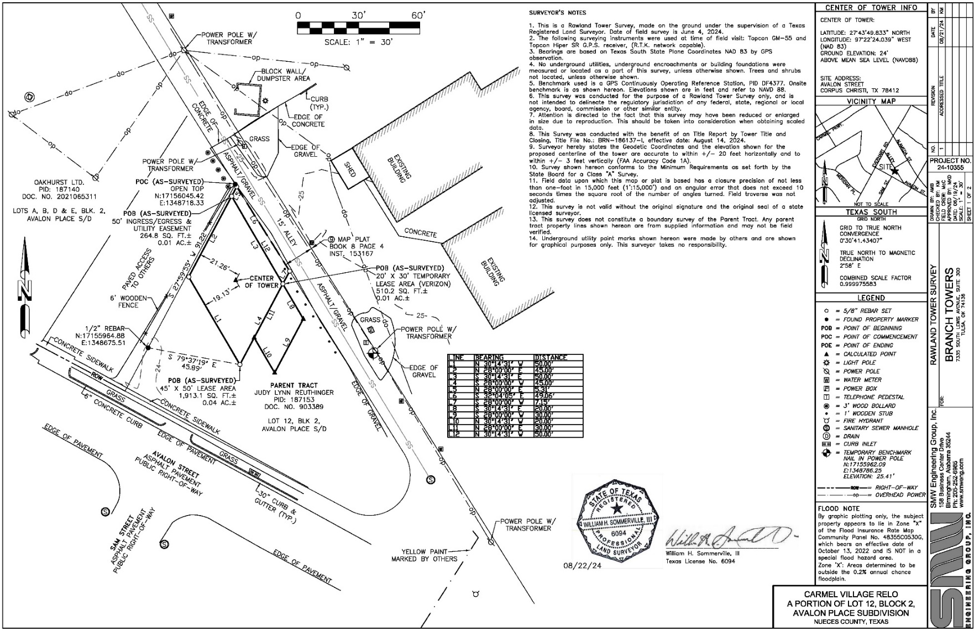
- Metes & Bounds Description and Exhibit

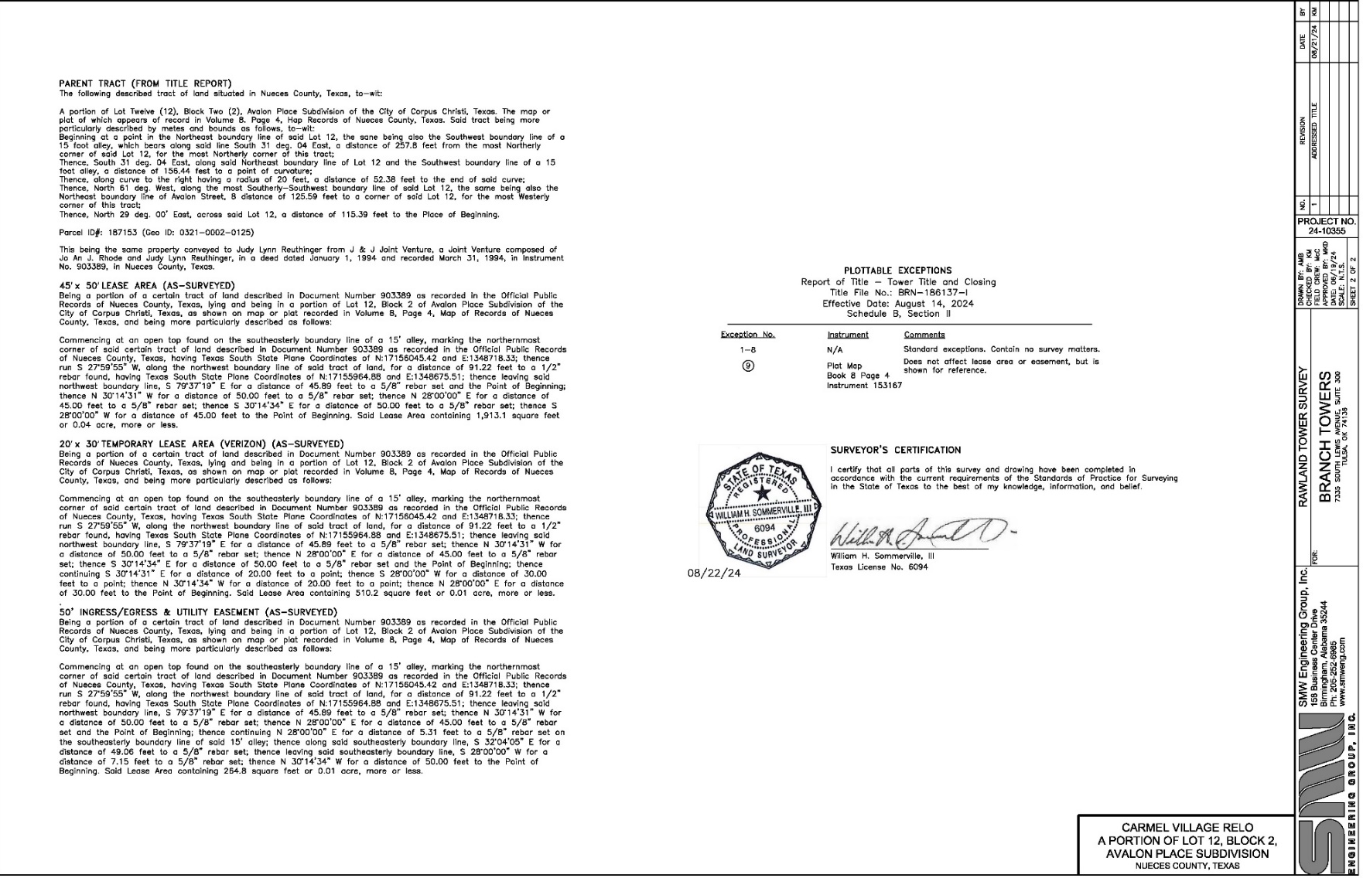

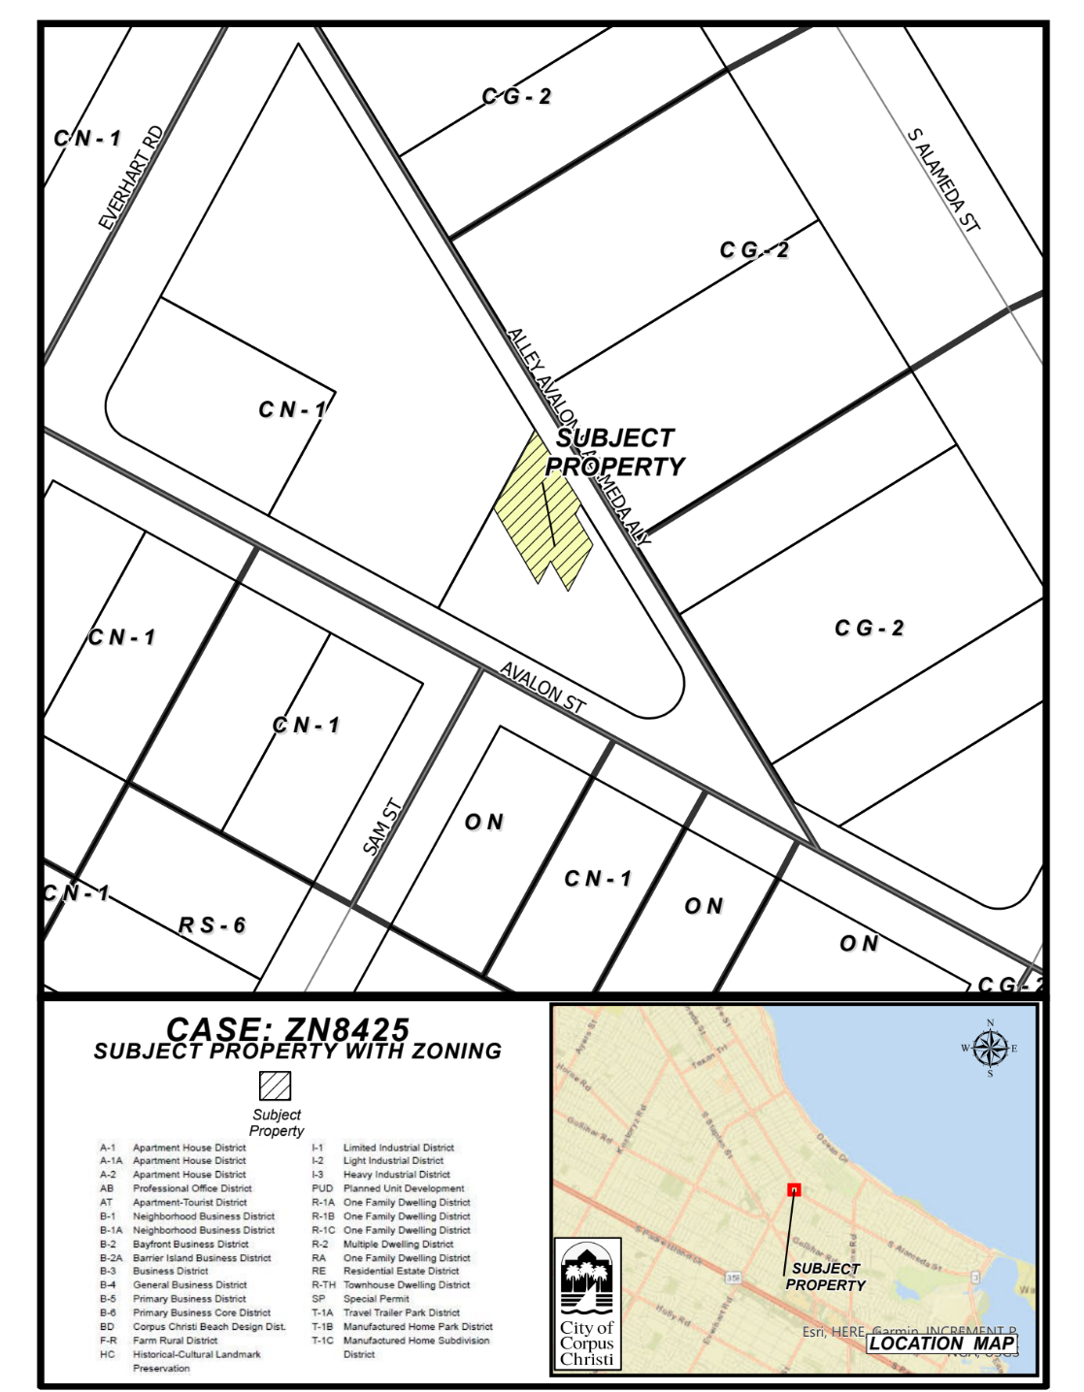
- Existing Zoning and Notice Area Map

