ZONING REPORT
Case ZN8425

Applicant & Subject Property
District: 2
Owner: Judy Lynn Reuthinger
Applicant: Branch Communications
Address: 4222 Avalon Street, located along the north side of Avalon Street, east of Everhart Road, and west of South Alameda Street.
Legal Description: 0.24 acres out of Lot 12, Block 2, Avalon Place
Acreage of Subject Property: 0.24 acres. Refer to Attachment (A) Metes and Bounds.
Pre-Submission Meeting: August 5, 2024
Zoning Request
From: “CN-1” Neighborhood Commercial District
To: “CN-1/SP” Neighborhood Commercial District with a Special Permit
Purpose of Request: To allow a 3 carrier, 120’ tall wireless telecommunication tower.
Land Development & Surrounding Land Uses
 | Zoning District | Existing Land Use | Future Land Use
Site | “CN-1” Neighborhood Commercial | Vacant | Commercial
North | “CN-1” Neighborhood Commercial,  “CG-2” General Commercial | Commercial,  Transportation (Avalon/Alameda Alley) | Commercial,  Transportation (Alley)
South | “ON” Neighborhood Office,  “CN-1” Neighborhood Commercial | Transportation (Avalon Street, Sam Street, & Avalon/Alameda Alley),  Commercial,  Professional Office | Transportation (Avalon Street, Sam Street, & Avalon/Alameda Alley), Commercial
East | “CG-2” General Commercial | Transportation (Avalon/Alameda Alley), Commercial | Transportation (Avalon/Alameda Alley),  Commercial
West | “CN-1” Neighborhood Commercial | Commercial,  Transportation (Avalon Street, Sam Street), Low-Density Residential | Commercial,  Transportation (Avalon Street, Sam Street),  Medium-Density Residential
Plat Status: The subject property is not platted per MRNCT (Map Records of Nueces County, Texas). Platting of the property must be preceded by zoning.
Military Compatibility Area Overlay District (MCAOD, Effective August 22, 2022): The subject property is not within a MCAOD District.
Code Violations: None.

Transportation and Circulation
Avalon Street | Designation | Section Proposed |  | Section Existing
Avalon Street | “Local” Residential | One thru Lane,  On-street parking (One Side)  40 feet |  | One thru lane,  On-street parking  (One Side)  40 feet
Transit: The Corpus Christi RTA provides service to the property at Avalon Street and Alameda Street via Bus Route 5 Alameda, and near Alameda and Everhart Road.
Bicycle Mobility Plan: The subject property is approximately 400 feet away from a proposed Bike Boulevard along Robert Drive.
Utilities
Gas: A 2-inch coated steel active line exists along the east side of South Alameda Street.
Stormwater: A 24-inch RCP (active and public) line exists along Avalon Street.
Wastewater: An 8-inch VCP (active and public main) line exists along the Avalon/Alameda alley.
Water: A 6-inch PVC (active and public distribution) line exists along the Avalon/Alameda alley.
Corpus Christi Comprehensive Plan (Plan CC)
Plan CC: Provides a vision, goals, and strategies, to guide, regulate, and manage future development and redevelopment within the corporate limits and extraterritorial jurisdiction (ETJ) which was adopted in 2016.
ADP (Area Development Plan): According to Plan CC the subject property is located within the Bayside Area Development Plan (Adopted on December 10, 2024).
Water Master Plan: No improvements have been proposed.
Wastewater Master Plan: No improvements have been proposed.
Stormwater Master Plan: No improvements have been proposed.
Roadway Master Plan: No improvements have been proposed.
Public Notification
Number of Notices Mailed |  |  | 17 within a 200-foot notification area
 |  |  | 5 outside 200-foot notification area
In Opposition |  |  | 0 inside the notification area
 |  |  | 0 outside the notification area
 |  |  | 0 % in opposition within the 200-foot notification area (0 individual property owners)
Public Hearing Schedule
Planning Commission Hearing Date: December 11, 2024
City Council 1st Reading/Public Hearing Date: January 14, 2025
City Council 2nd Reading Date: January 28, 2025

Background:
The subject property is a vacant and undeveloped, 0.24-acre tract located along the north side of Avalon Street, between Everhard Road and Caramel Parkway. The area is characterized primarily by commercial properties, with primary arterials to the east and west.

The subject property abuts the Avalon/Alameda alleyway along its northern and eastern boundaries, with commercial uses further north. Some properties are zoned “CG-2” General Commercial, while others are zoned “CN-1” Neighborhood Commercial. To its east, continues the Avalon/Alameda alleyway, and further east are properties zoned “CG-2” General Commercial and “ON” Neighborhood Office, with commercial uses. To the south of the site and Avalon Street, properties are zoned “ON” Neighborhood Office and “CN-1” Neighborhood Commercial, with commercial uses. To the west, properties are zoned “CN-1” Neighborhood Commercial, with transportation (Avalon Street and Sam Street), commercial, and low-density residential uses.

The applicant is requesting to amend the current zoning district to allow with a special permit to accommodate a wireless telecommunication tower with support equipment.

The “CN-1” Neighborhood Commercial District permits restaurants, apartments, townhouses, overnight accommodation uses, educational facilities, medical facilities, commercial parking, offices, retail sales, personal services, vehicle sales and services, water-oriented uses, and minor utilities.

Plan CC (City of Corpus Christi Comprehensive Plan) Consistency:
The proposed rezoning is consistent with the following Elements, Goals and Strategies for Decision Makers:
- Future Land Use, Zoning, and Urban Design
  - Corpus Christi development patterns support efficient and cost-effective use of resources and high-quality life.
    - Promote a balanced mix of land uses to accommodate continuous growth and promote the proper location of land uses based on compatibility, locational needs, and characteristics of each use.

Bayside ADP (Area Development Plan) and FLUM (Future Land Use Map) Consistency:
The proposed rezoning is generally consistent with the Southeast ADP; however, is not consistent with the future land use designation of commercial.

Staff Analysis:
Staff reviewed the subject property’s background information and the applicant’s purpose for the rezoning request and conducted research into the property’s land development history to include platting, zoning, existing surrounding land uses, and potential code violations. Staff compared the proposed zoning’s consistency with the applicable elements of the comprehensive plan. As a result of the above analysis, staff notes the following:
- The proposed rezoning is consistent with the City of Corpus Christi comprehensive plan; however, is not consistent with FLUM designation of commercial.
- The proposed rezoning is compatible with the present zoning and conforming uses of nearby property. It is a utility use permitted in residential and commercial districts. It is suitable for the uses permitted by the zoning district that would be applied by the proposed amendment and will not have any adverse impact on the character of the surrounding area and neighborhood. A 120’ tall monopole tower, that is rated to 143 mph wind speed, is being proposed, which is a more fitting aesthetic across the range of telecommunication facility design. The development was reviewed and deemed acceptable by the Technical Review Committee.
- During the permitting process, zoning reviews are conducted to ensure that development compatibility is achieved; through the prescription of Unified Development Code required buffer yard width and points (UDC §7.9.5, 7.9.6), increased setbacks due to height (UDC §4.2.8.D), limitations on hours of operations with certain site features (UDC §7.2.7.B.1.a), and visual barriers such as landscaping (UDC §7.3.10) and walls to buffer noise generators (UDC §7.9.8.B).

Staff Recommendation:
After evaluation of case materials provided and subsequent staff analysis including land development, surrounding uses and zoning, transportation and circulation, utilities, Comprehensive Plan consistency, and considering public input, Planning Commission and Staff recommend approval of the change of zoning from the “CN-1” Neighborhood Commercial District to the “CN-1/SP” Neighborhood Commercial District with a Special Permit.

Attachments:
- Metes & Bounds Description and Exhibit
- Existing Zoning and Notice Area Map
- Metes & Bounds Description and Exhibit
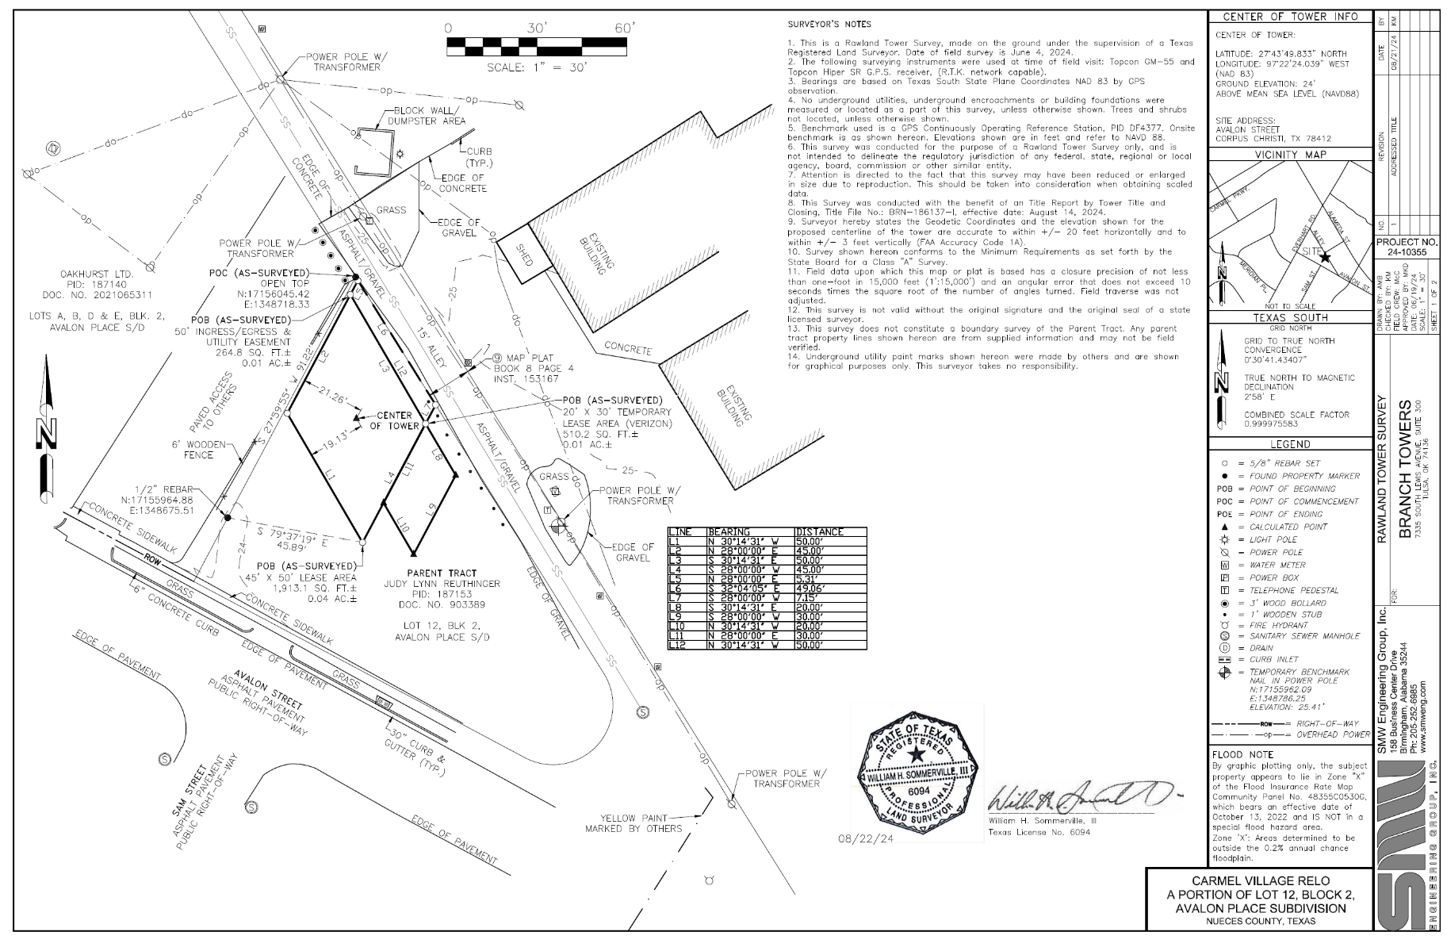

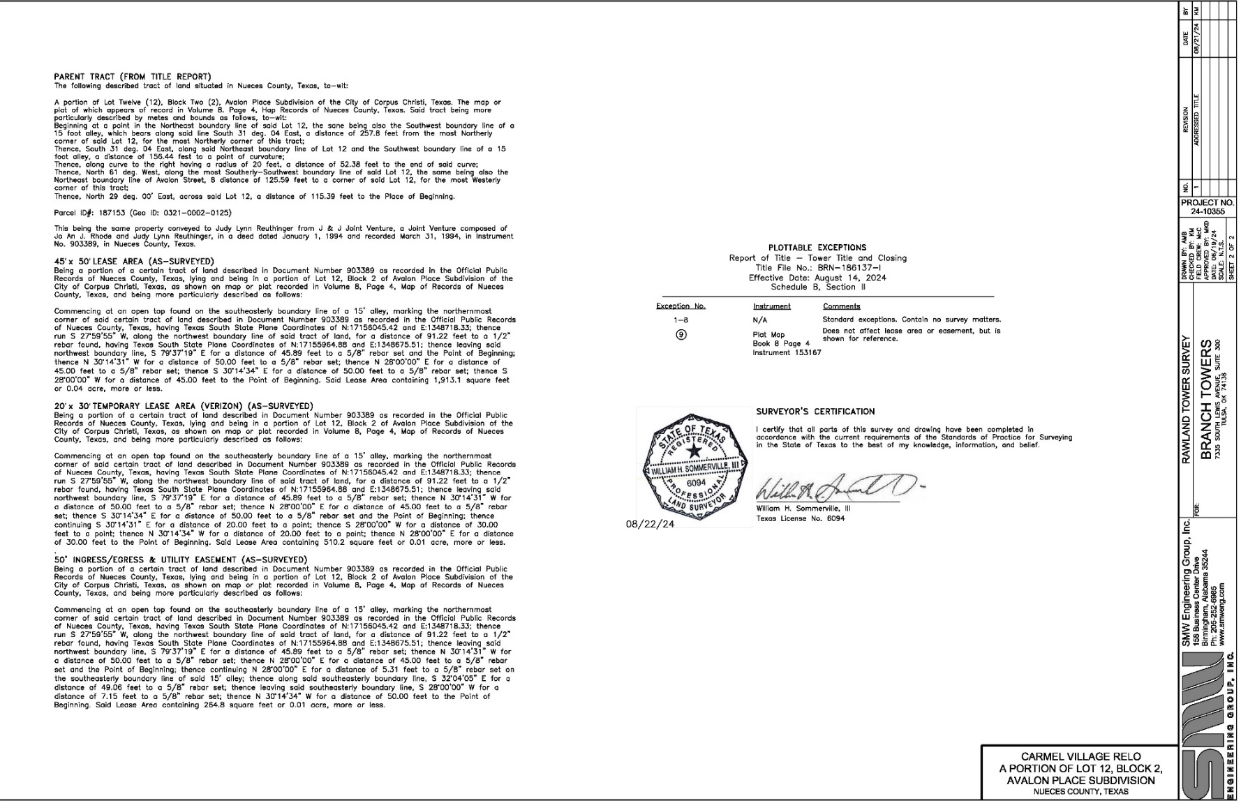
- Existing Zoning and Notice Area Map

